### 

### ­­

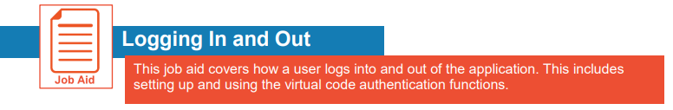



**Accessing the Mobile Application**



The Mobile Application allows users to access the application with a mobile device such as a mobile phone or tablet. This job aid shows how to access and log into the mobile application.

|  |  |  |
| --- | --- | --- |
| **1 - Download App - Android** |  | **1 - Download App - Apple iOS** |
| * Access **Google Play** * Search for “**HCMToGo**” * **Download** and **Instal**l the application to your device | 1 | * Access the **Apple App Store** * Search for “**HCMToGo**” * **Download** and **Install** the application to your device |

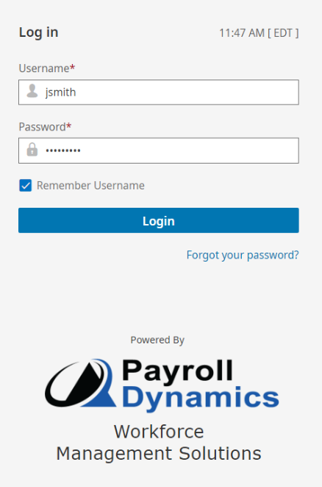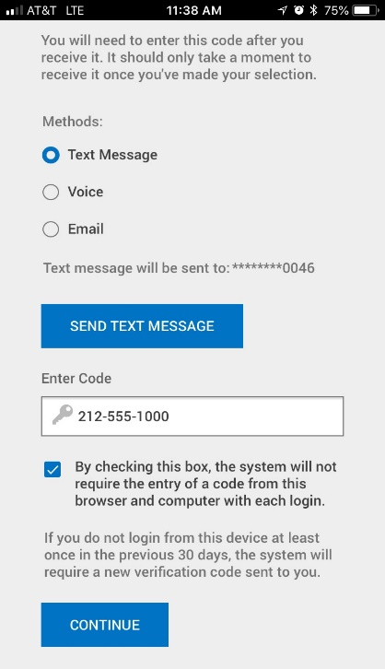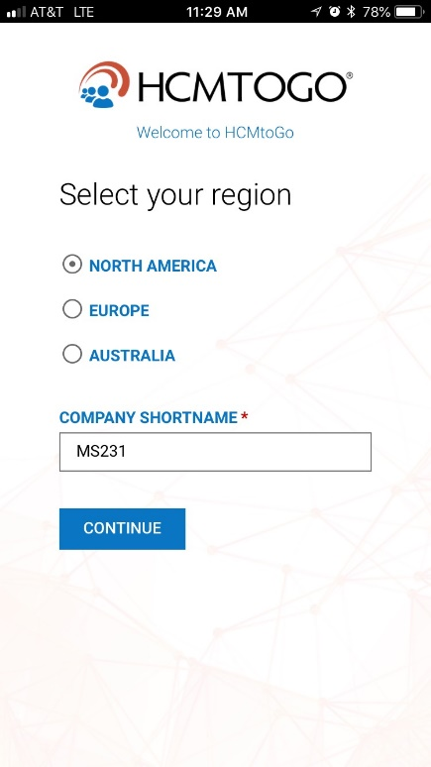

3

2

|  |
| --- |
| **2 - Setting Up the Mobile App** |
| * Open the mobile application on your device * **Select your region** from the list * Enter **Company Shortname** “**XXXXX**” * Press **CONTINUE**   * Request your Company Shortname from payroll |

VQ200

4

|  |
| --- |
| **3 - Logging In** |
| * Enter **Username** (first initial of your first name and your entire last name. For example. John Smith would be jsmith) * Enter **Password** (First time Users enter last 4 digits of SSN) * Press **LOGIN** |
| **­­­Changing Your Password** |
| Password must be at least **8 characters** and must contain **each** of the following:   * **Upper Case Letter** * **Lower Case Letter** * **Number** * **Symbol**   Example: Password1! |

|  |
| --- |
| **5 - Success!** |
| The following message should appear once you have successfully logged into the mobile app. |

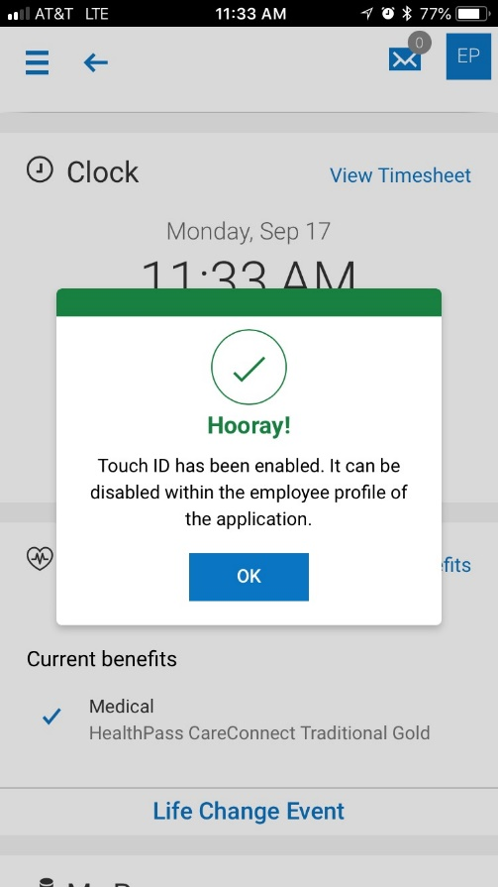

TIP  Make sure Location Services is turned on in your device settings

5

|  |
| --- |
| **4 - Virtual Code / Register Device** |
| * **Select your preferred method** for receiving a code. Text Message, Voice (Phone) or Email * **Press Send** Text Message/Send Email/Send Call * Enter the 6 digit **verification code** * **Check the Box** to remember the device (Recommended) * Press **CONTINUE** |